**Title**

MANTIS HRMS

**Team members: Professor:**

General, Jeri Luther Mr. Manuel Sebastian S. Sanchez

Alpapara, Johann Paul Romero **Project Adviser:**

Siccion, Justine Mark Siccion Ms. Verna Rosario V. Villacorta

1. **Introduction**

**Project Context**

The MANTIS, a Human Resource Management System, focuses on improving the human resources management processes. Its purpose is to remove the Paper-based Leave Application and Tracking, help remove the Manual Employee Performance Evaluation, avoid the significant use of staff time, avoid the Duplication of Effort, and to remove the many instances of Human Error.

The main problem of this project is the need for an affordable, simple, systematic and flexible HR solution that would manage every aspect of its human resources. There is no system yet being used by the client of this project. Therefore, the developers will need to provide a complete and customizable HR Solution that enables organization to perform all HR operations with ease

**Purpose and Description**.

MANTIS Human Resource Management System (MANTIS HRMS) will provide a complete and customizable HR Solution that enables organization to perform all HR operations with ease. It is expected to have a secure, web-based system that allows employees to update their information, apply for leave, track leave applications, view employee performance appraisal and more, anywhere and anytime.

A MANTIS Group member, Johann Alpapara, has a connection with the HR Department through his Mother who is working in the HR Department of the City Government of Paranaque prompting the group to take the HR Department of the City Government of Paranaque as a client. With a series of questions asked to the client, the group found out that there are time consuming activities that is still being practiced by the HR Department that can be fixed by using a Human Resource Management System for the Department’s processes. The developers recommended to the client to develop a HRMS Solution for use of the HR Department. Through with this system, it also aims to increase the efficiency on processing information by the HR Department and also aims to reduce the instances of human errors.

**Objectives**

**General Objectives**

* To remove the paper-based processing of information.
* To maximize the use of staff time and energy.
* To avoid the instances of human errors.

**Specific Objectives**

* To have faster processing of information.
* To provide the client with a human resource management system.
* To implement the system to the Human Resources Department.

**Scope and Limitations**

The MANTIS HRMS only covers the processes needed by the Human Resources Management Department. The coverage of this project is the Personal Information Management, Leave /Time off Management, Time & Attendance Management, Employee Self-Service Access, and Recruitment. Only the Management and Admins can fully access the system, employees can access the system but is limited to access to only a number of system functions.

1. **Review of Related Literature/Systems**

**OrangeHRM**

OrangeHRM is the world's most popular and used open source human resource management software. The open source OrangeHRM product suite includes an array of modules that provide personal information management (PIM), employee self-service (ESS), leave management, time and attendance tracking (PTO), performance evaluation and recruitment, all at no cost. Today OrangeHRM is being used by over a million users around the world, while larger multinationals have used the open source version and customized the system to meet their human resource management standards & requirements. (Retrieved on July 16, 2016 from <https://www.orangehrm.com/OrangeHRM_AboutUs>)

Orange HRM is a resource management tool for any SMB or enterprise looking for a cost-effective tool to manage a large number of human resources tasks in a Web-based, user-friendly tool. And with the ability to purchase support, add-ons, customizations, and even hosted services, OrangeHRM should appeal to any size business. OrangeHRM solves the often daunting task of managing all aspects of employees/staff and does so without the usual steep learning curve associated with many HRM tools. OrangeHRM is quickly becoming the de facto standard for open source human resource management tools. No matter the size of your business, your human resources department could easily benefit from an OrangeHRM installation. (Retrieved on July 16, 2016, from<http://www.techrepublic.com/blog/product-spotlight/review-orangehrm-human-resource-management-tool/>)

**Sentrifugo**  
  
 Sentrifugo is an intuitive and easy to use Open Source Human Resource Management Software supported by Sapplica Info Technologies. Designed for flexibility, Sentrifugo is for organizations of different sizes to manage their employee statistics and dynamic data efficiently and effectively. Sentrifugo ideally provides employee self-service, absence management, resource requisition, reports and analytics and other Human resource management tools which can be customized to reflect the unique work flow and processes of an organization. Thus, increasing efficiency of the organization and subsequently integrating and aligning the efforts of HR with the rest of the organization. Sentrifugo is licensed under the terms of GNU General Public License version 3. (Retrieved on July 16, 2016 from<https://sourceforge.net/p/sentrifugo/wiki/Home/>)

Sentrifugo allows the administrator to configure the settings that reflect unique workflow to establish and maintain consistency throughout the application. The employee and site configurations contain all the features that are essential for effective human resource management. Site Preferences, on the other hand, handles the default date-time, currency and password formats for the organization. However, only the privileged users of the application can configure the features at any point of time, to meet the current and future needs of the organization. (Retrieved on July 16, 2016 from <https://sourceforge.net/p/sentrifugo/wiki/Home/>)

**WaypointHR** 

WaypointHR provides a flexible Human Resource Information System (HRIS) developed by HR-Fundamentals ltd, primarily for UK, European and US employers. WaypointHR streamlines the process of storing essential personnel records such as employee contact details, job description and salary in an easy and efficient way. WaypointHR is available in two version the free one and On-Demand. For the free version employee data of the organization is stored in the in-house servers. In case of WaypointHR On-Demand system employee data in stored in their secure data center on the WaypointHR servers. In both versions WaypointHR retain full employee history, and allow the user to create employee records and company reports. WaypointHR features a web based interface. It requires no special or technical skills to use the system. WaypointHR is an open source which would benefit from fast growing community of users, software developers and business professionals. With efforts from all these corners for WaypointHR will surely thrive as a freely available software platforms that end users can adopt and rely on. (Retrieved on July 16, 2016 from<http://tech.gaeatimes.com/index.php/archive/waypointhr-overview/>)

**IceHRM**   
  
 IceHrm is a Human resource management system for small and medium sized organizations. It covers all the basic HRM needs of a company such as leave management, time management and handling employee information. IceHrm is a Human resource management system for small and medium sized organizations. It has a rich UI built with PHP and Java Script. The system is implemented with a modular architecture which makes it extendable and can be customized easily. (Retrieved on July 16, 2016 from <http://blog.icehrm.com/docs/home/#what-is-icehrm> and<http://www.slideshare.net/thilinah1/ice-hrm-administrator-manual>)

1. Technical Background

The MANTIS HRMS is an HR Management System with different modules for the different functionalities of the system. The system will have 7 specific modules:

System Administration Module

The System Administration module offers centralized control to your HR Manager or other personnel to carry out basic HR functions. Define your organizational structure or your pay scale with this module. Work in a secure environment to manage core information and business projects or address security issues such as user rights and permissions.

Personnel Information Management (PIM) Module

As a centralized employee database, the Personal Information Management (PIM) gives you the capability to easily and productively store and utilize all aspects of your employee information.

Leave /Time off Management Module

Using web-enabled and self-service concepts, management of vacation and leave requests was never easier. This integrated module enables online processing of requests and approval for leave and vacation time. Significantly streamline all your leave-related procedures‚ eliminate paperwork and reduce scheduling hassles with this module.

Time & Attendance Management Module

Eliminate paperwork and manual management of attendance and project timekeeping with this sophisticated HR module. The Time and Attendance Management module automates your timekeeping-related processes while minimizing attendance policy errors. Enhance organizational performance and keep your labor and workforce data effectively organized.

Recruitment Module

The Recruitment module gives HR professionals a comprehensive solution for the entire recruitment cycle. Effectively streamline your applicant tracking process from job vacancy to hire.

Employee Self Service Module

Employee self service (ESS) is a powerful module that provides employees access to pertinent information through a web-enabled PC without involving HR staff. Subject to your information and security policies, employees can view and update personal information, providing tremendous time and cost savings. The functionality of this module spans the entire system‚ making information available anywhere‚ anytime.

Dashboard Module

The Dashboard module integrates information from multiple modules into a unified display. The module gives you a clean, user-friendly interface with real-time trend graphs, lists of pending HR tasks, quick launch panel and reporting.

**Sample input/output/Reports**

**Use Case Diagram**

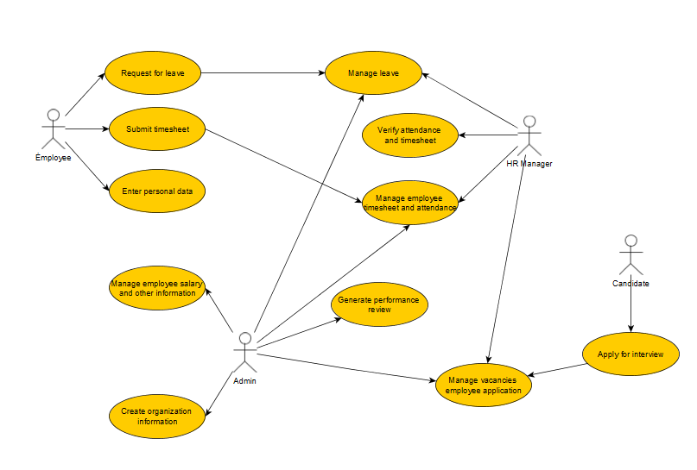

**Event Table**

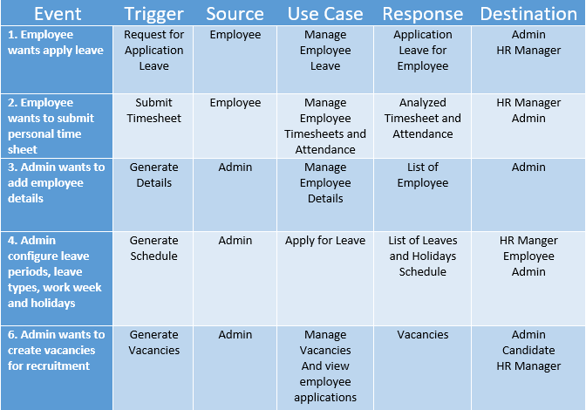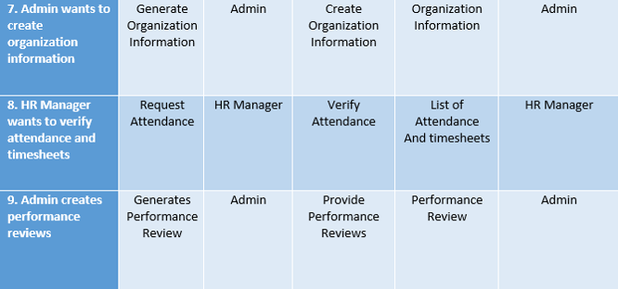

**Class Diagram**

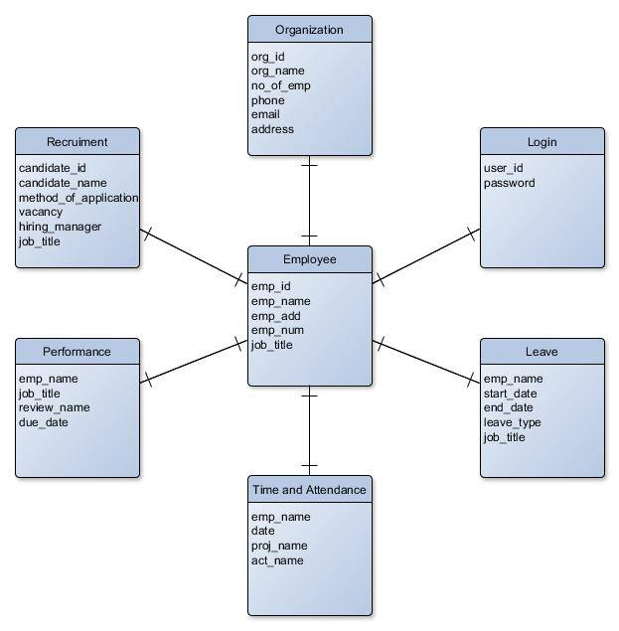

**Context Diagram**

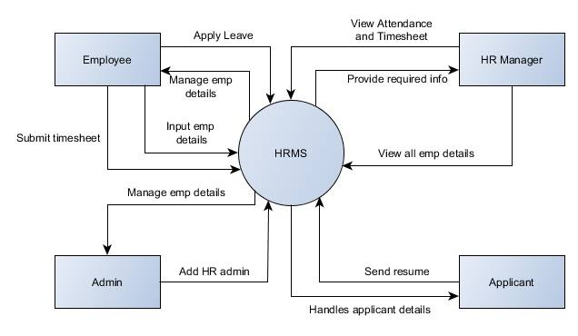

**DFD LVL 0**

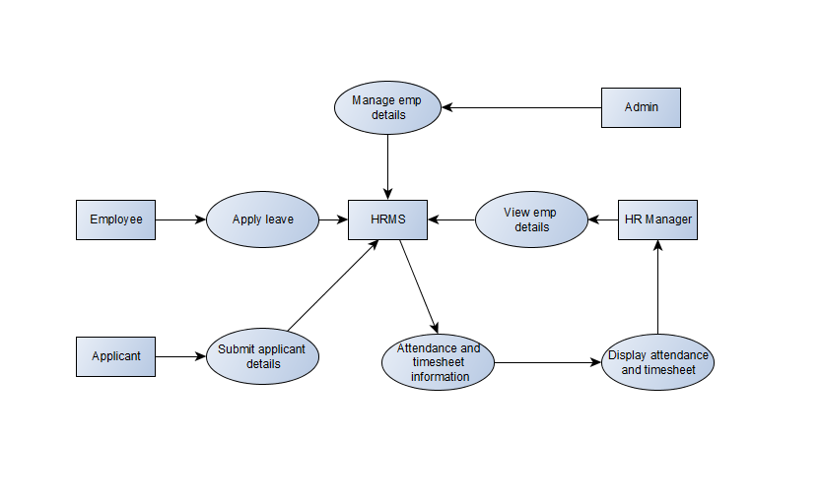

**ERD**

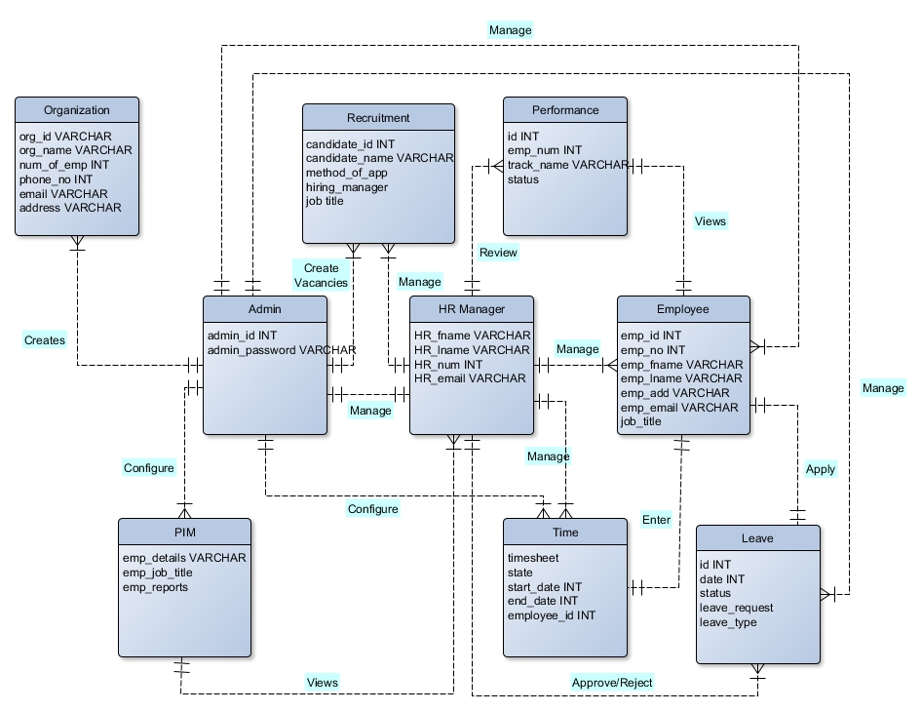

**Composite Structure Diagram**

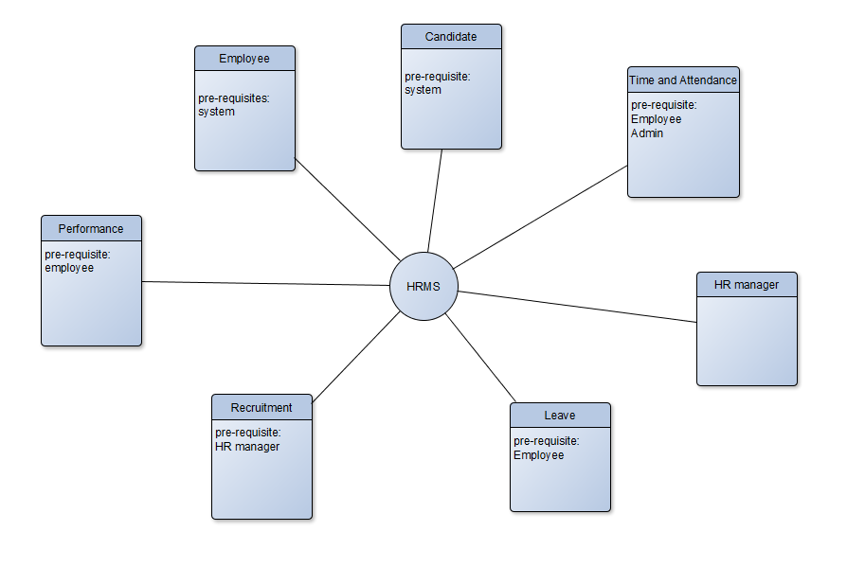

**Object Diagram**

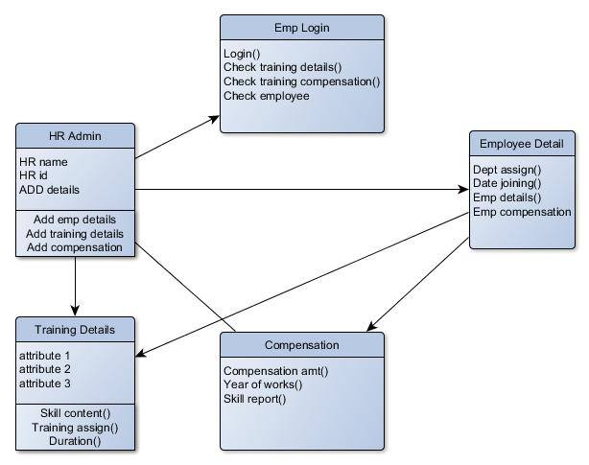

**State Diagram**

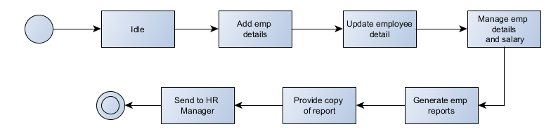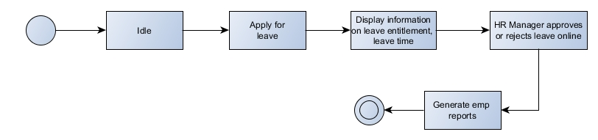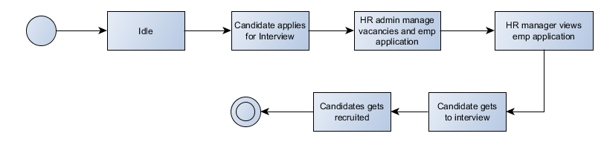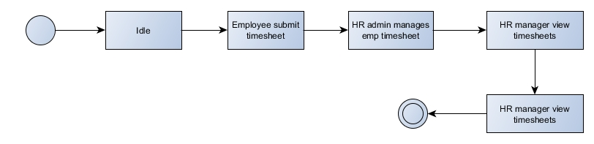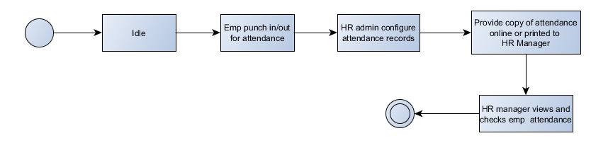

**Sequence Diagram**

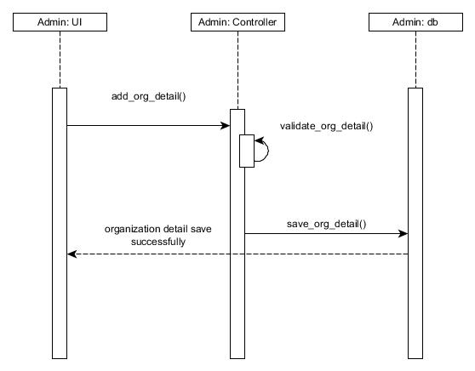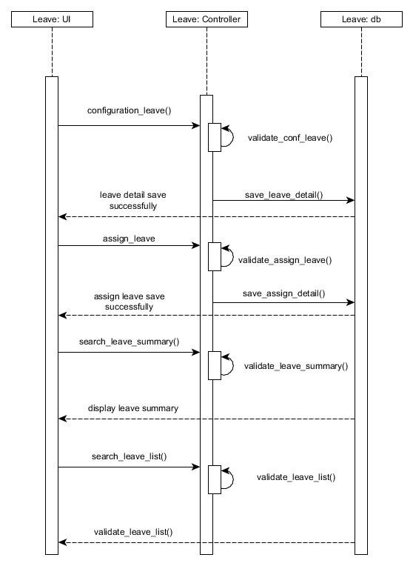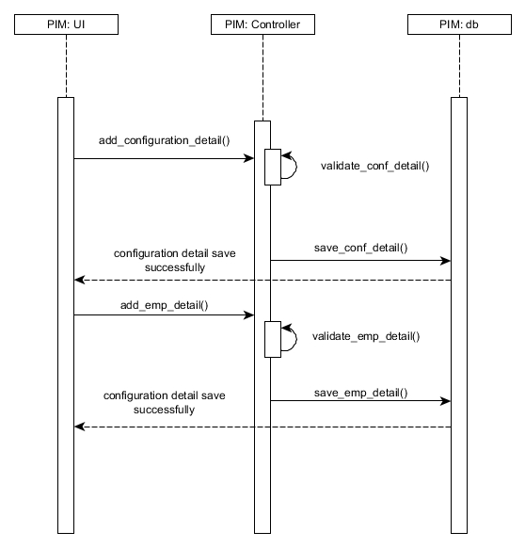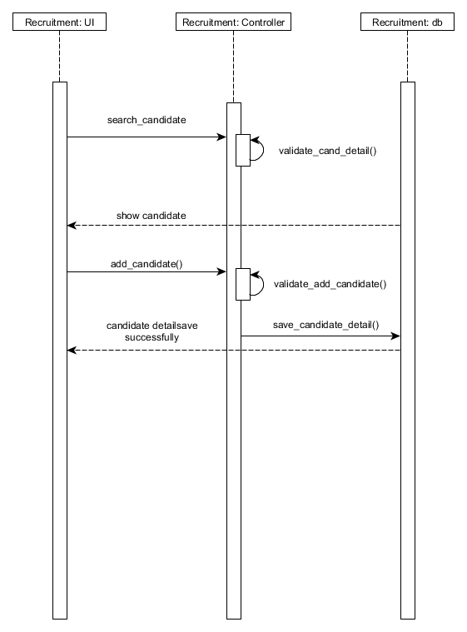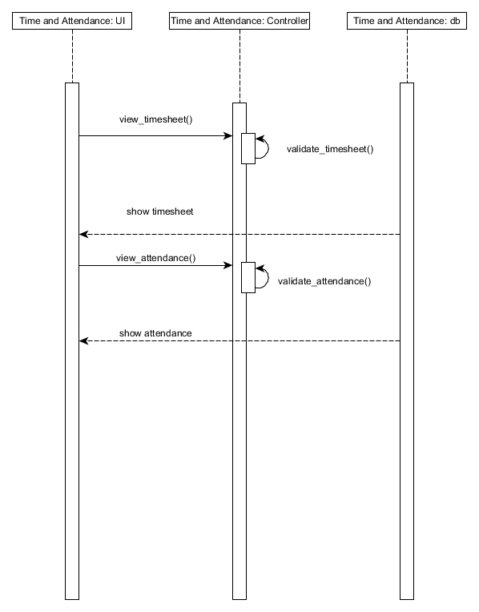

**Timing Diagram**

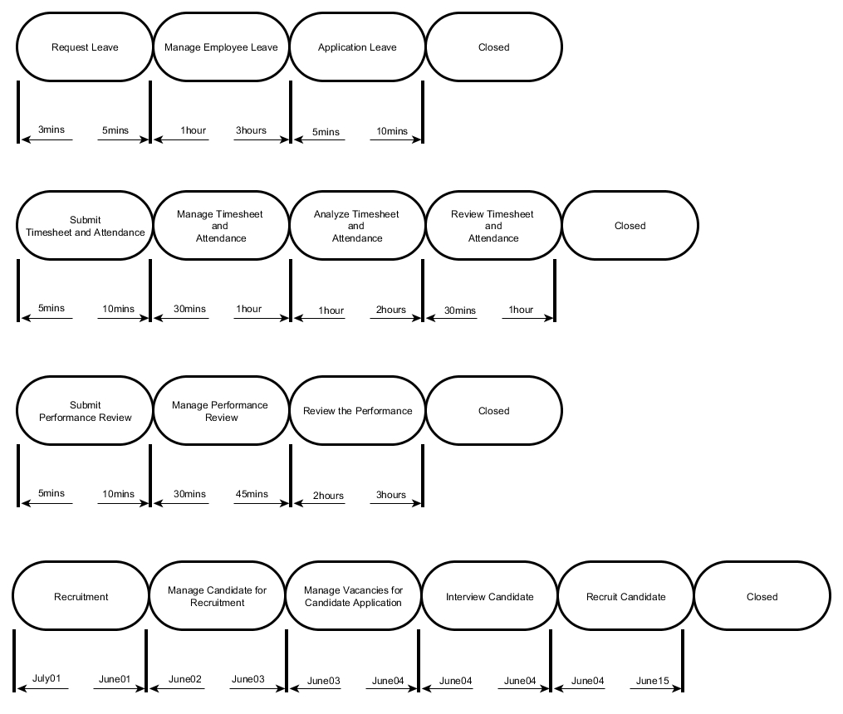

**Activity Diagram**

